Proceedings of Workshop
On
Developing a Conservation Strategy & Action Plan for Hill Wetlands
At The Taj Savoy, Ooty and Keystone Foundation, Kotagiri
15 & 16 September 2006
Organized by Keystone Foundation
with support from IUCN, Netherlands Committee

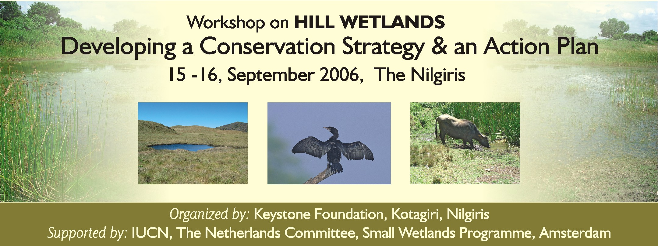
List of Participants
- Prof. K C Malhotra, Resource Person on Natural Resources, New Delhi
- Dr. Ms. Suprava Patnaik, Associate Prof. Indian Institute of Forest Management, Bhopal
- Ms. Jayati Chourey, PhD Student, Forest Research Institute, Dehra Dun - working on Wetlands of Andhra Pradesh
- Mr. B.J Krishnan, Save Nilgiris Campaign & Environment Law – IUCN, Ooty
- Dr. Narendra Prasad, Sr. Principal Scientist, SACON, Hyderabad
- Mr. Rathin Barman, Aaranyak, Guwahati Assam
- Mr. Raman Dharmalingam, Coffee Planter, Ooty, Nilgiris
- Dr. Madhu, Head, Central Soil & Water Conservation Training & Research Institute, Ooty
- Mr. A.Venugopal, Tourist Officer, Ooty
- Mr. S.Dorairaj, Assistant Tourist Officer
- Mr. S.Balashanmugham, Assistant Engineer, TWAD Board, Ooty
- Mr. K.Elangovan, Assistant Engineer, TWAD Board, Ooty
- Mr. Ramesh Bellia, President-Nilgiris Vegetables Farmers Association (Badagas),Ooty
- Mr. K.M. Nanjan, Nilgiris Vegetables Farmers Association (Badagas),Ooty
- Mr. Madhusudan Sreenivasan, Researcher, USA
- Mr. Kutarada Kuttan, Toda
- M. Shivam, Kota
- Mr. Jaganathan, Kota
- Mr. Mohan Kumar, Kota
- Mr. Samant Raj, Toda
- Mr. Ramnik Singh, Toda Researcher, EBR – Botanical Refuge Trust, Ooty
- Mr. J.K.Mohan Kumar, Earth Trust
- Mr. Mohan Raj, WWF, Ooty
- Mr. Dharmalingam, Ooty
- Mr. Joakim Lindberg, Liaison Officer, Swallows India
- Mr. Elle Bergsten, Sweden
- Ms. Samita, Keystone
- Mr. Senthil, Keystone
- Mr. Robert Leo, Keystone
- Mr. Mathew, Keystone
- Ms. Anita, Keystone
- Ms. Shiny, Keystone
- Mr. Kunal, Keystone
- Mr. Pratim, Keystone
- Mr. Sumin, Keystone,
- Mr. R.Eswaran, Keystone
- Ms. Priya, Keystone
- Ms. Sara, Keystone

Program

Day 1:
0930 hrs – 1100 hrs: “Hill Wetlands – History & Current Situation - Wetlands Conservation & Sustainable Management in the Nilgiris: Project Findings – Pratim Roy & Samita Vasudevan, Keystone Foundation”. Presentation of results for 50 minutes and discussion for 40 minutes.

1100 hrs – 1115 hrs: Tea

1115 hrs – 1215 hrs: Theme I: “Biodiversity, People & Wetlands – Livelihood & Conservation Aspects – Is there a model”? Lessons to be learnt from other places. Talk of 40 minutes with 20 minutes discussions and questions. Suprava Patnaik & Jayati Chourey, Indian Institute of Forest Management, Bhopal. Kondaava Wetlands, Andhra Pradesh.

1215 hrs – 1315 hrs: Theme II: “Laws, Legislation & Policy of Wetlands in India in general and in mountain areas specifically – Is there a way forward for active policy change” Talk of 40 minutes with 20 minutes discussions and questions. Talk by B.J Krishnan, Environmental Law Board, IUCN

1315 hrs – 1415 hrs: Lunch

1415 hrs – 1515 hrs: Theme III: “Methods to Assess Wetland Biodiversity Features” - Biodiversity tools, Sampling methods, population counts, environmental parameters – thumb rules and innovative approaches to gauge wetland health; indicator species. Talk of 40 minutes with 20 minutes discussions and questions Dr. Narendra Prasad, Senior Principal Scientist, Salim Ali Centre For Ornithology & Natural History, Deccan Regional Station

1515 hrs – 1615 hrs: Theme IV: Panel Discussion Official Stakeholders “Governance & Wetlands” – Perspectives from the Forest Department / Government / Civil Society – how is it dealt today; invisible resources”? Talk of 40 minutes with 20 minutes discussions and questions
Session: Facilitated by Prof. K.C Malhotra:

1615 hrs – 1715 hrs: Concluding Remarks of Day 1; plan of action for Day 2
Day 2:
0900 Departure to Kotagiri from Ooty:

1000-1100 Field Trip to Tirsigadi, Wetland, Kotagiri

1115 – 1100 hrs Proceeding to Keystone Centre

1130 – 1300 hrs: Facilitator Prof. K.C Malhotra
Form into 5 groups based on the 5 themes (Day 1) – with Government, Researchers / Biologists, NGOs, Indigenous People, Entrepreneurs (Tourism, Fishing, Eucalyptus oil distillation, etc.) as stakeholders

1300 – 1400 hrs: Lunch at Sylvan Hall, Kotagiri

1400 – 1700 hrs: Presentation by groups and discussions after each presentation – recommendations from each group to bring out the Nilgiris Declaration on Wetlands 2006 and beyond

End of Workshop

Day 1 at Ooty

Inauguration and Lamp lighting

With the arrival of delegates by 10 in the morning, Mr. Pratim Roy from Keystone Foundation initiated the program and called on Mr. K. C. Malhotra, Dr. Narendra Prasad, Dr.Suprava Patnaik and Mr. Mohan Raj from the guests and Mr. Robert Leo and Ms. Samita Vasudevan from Keystone to light the lamp and officially declare the session open.

Immediately after the lamp lighting ceremony, the conference room was darkened and Keystone presented its journey through the wetlands of the Nilgiris in the form of a short, inspiring movie. The short movie of three minutes comprised of photographs of the various wetland visited by the Keystone team, pristine wetland and totally degraded ones. The movie was a reminder to the delegates that so much has been lost over the past few years, yet much can be done to help preserve and protect the wetlands of the Nilgiris.

Welcome Note by Pratim Roy

As the movie concluded, Mr. Pratim Roy welcomed the guests and speakers who had assembled from various parts of the country as well as the Nilgiris. There had been some changes in the list of speakers and he announced the revised schedule that would be followed for the day.

Presentations and Discussions

The first presentation was by Keystone who spoke about the survey findings of
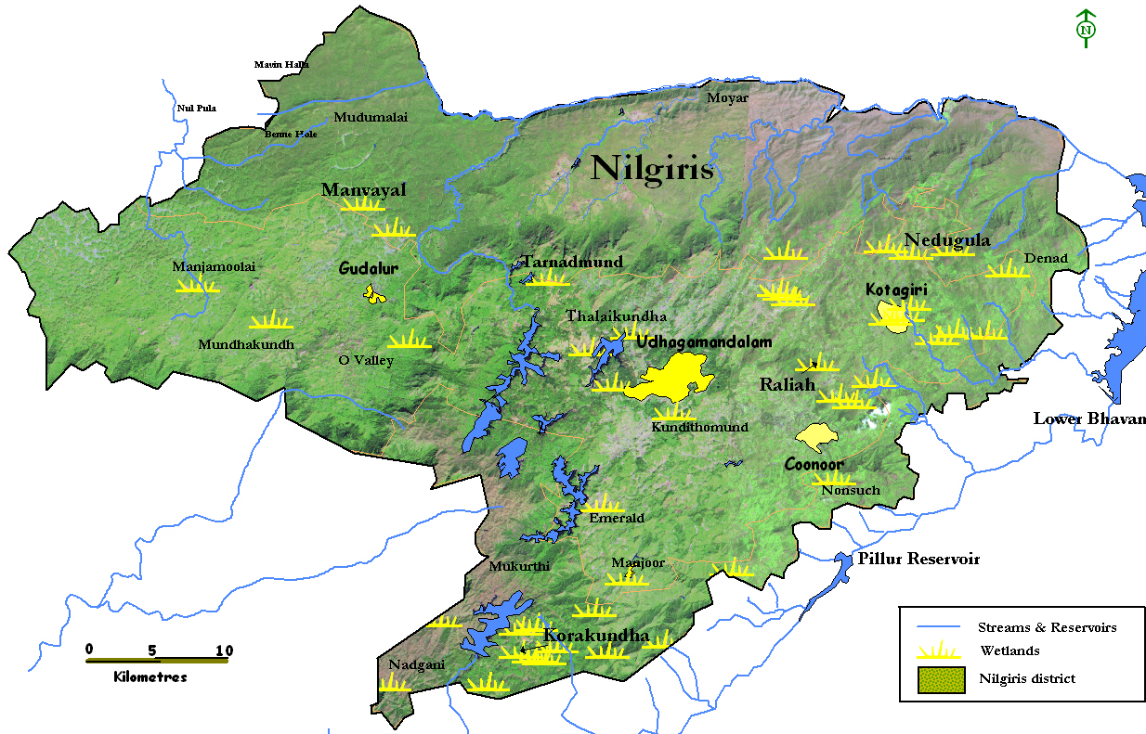
‘ The Hill Wetlands – History & Current Situation - Wetlands Conservation & Sustainable Management in the Nilgiris’ by Pratim Roy and Samita Vasudevan. Mr. Roy started with explaining about the hill wetlands of the Nilgiris and with the help of a GIS map, illustrated the spread of wetlands in Nilgiris.

An important component of the presentation was the historical link between indigenous people of Nilgiris and the wetlands. The Todas, Badagas, Kotas, Chettis, Irulas and Kurumbas, all indigenous people of the Nilgiris were intrinsically linked to the wetlands.
He explained that the Todas who were pastoralists held wetlands sacrosanct and the presence of a wetland was an important criteria for establishing the ‘Mund’ along with grasslands and Sholas.
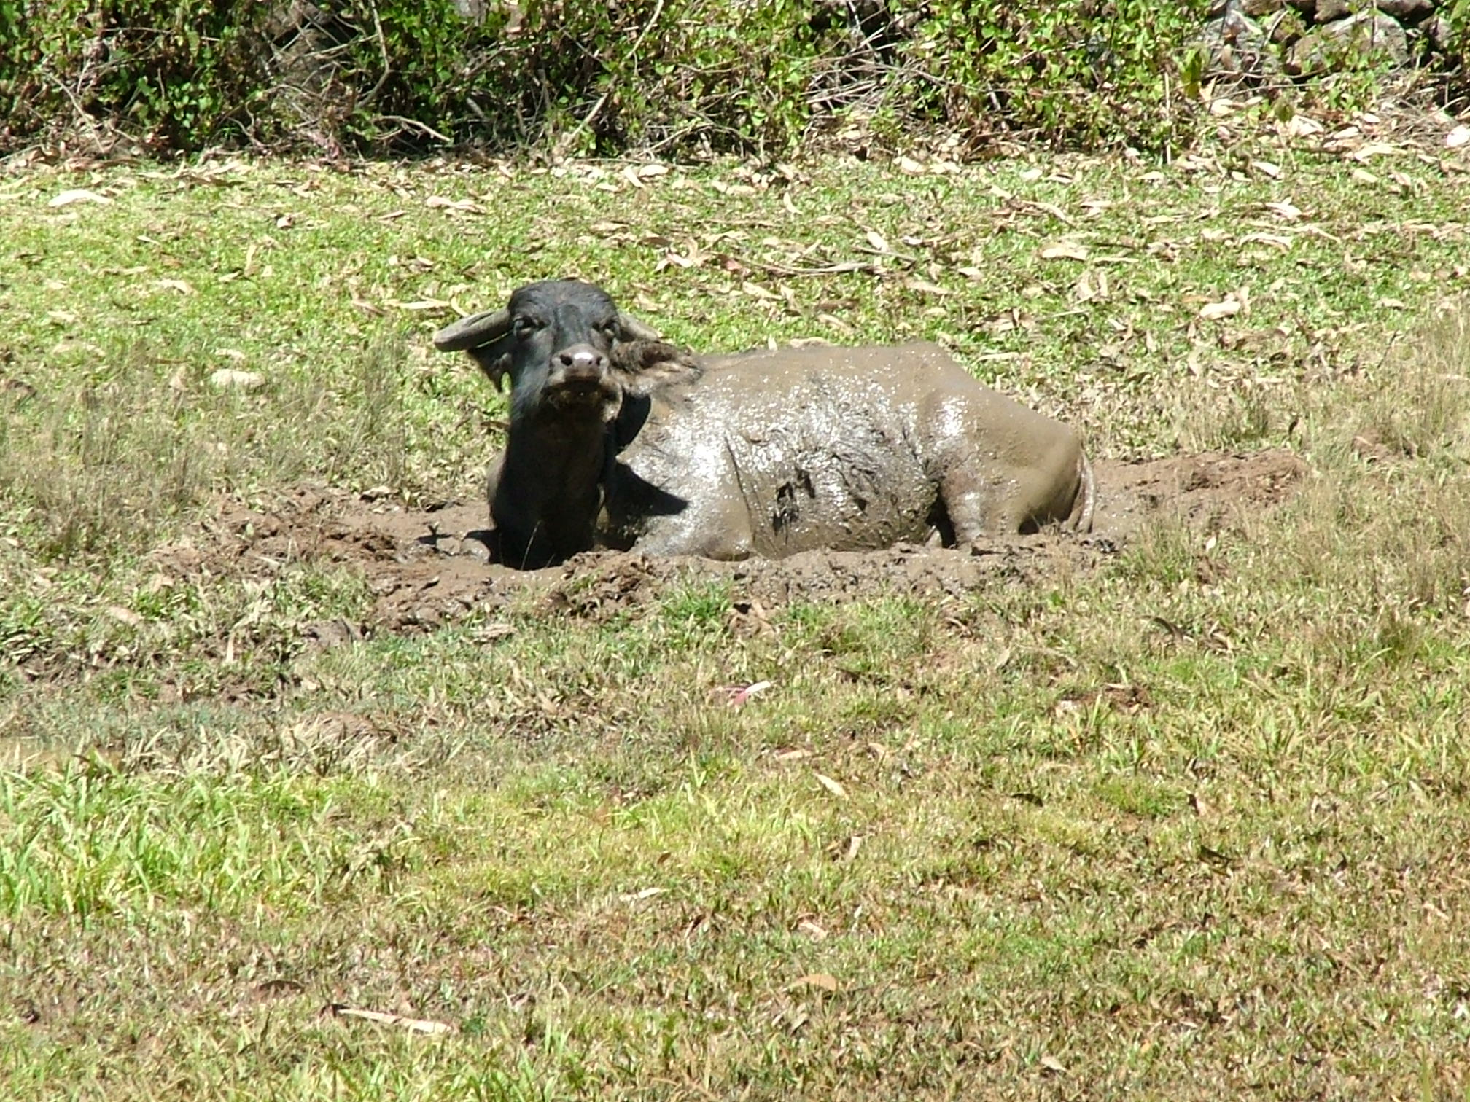
The Badagas were agriculturalists and kept buffaloes also. The buffalo hides were traded with the Kotas in exchange for agricultural instruments.

The Kotas who were known for their pottery skills used the clay from these wetlands for making pottery. The Chettis occupying the lowlands of Nilgiris have been doing wetlands agriculture since years. Finally, the Irulas and Kurumbas, both forest dwellers used these wetlands as hunting grounds.

The presentation was taken forward by Ms. Samita Vasudevan who explained the objectives and methodology of the work undertaken. She spoke about the finding from the survey of 38 wetlands covering various physical, biological parameters as well as threats to the wetlands. Based on these findings, the wetlands were classified as those which were common property resources, under private land as well those which were protected by the forest department. The wetlands classified as CPRs (Common property resources) are found in the urban and rural areas. All such wetlands identified and surveyed were found to have various management issues depending on its legal status and a more detailed intervention strategy has been detailed out in the comprehensive report that forms an important output of the project. The presentation also focused on the future action plan of various activities to be undertaken like nursery, awareness campaigns as well as preparation of local management plans.

The tempo for the next presentation was set by the concluding slide which focused on the utter neglect and appalling state of wetlands in the Nilgiris. Above all, it drew the attention of the participants to the ownership questions which the team very often came across while undertaking the survey ‘wetlands belong to whom?’

Discussions: Mr. Nanjan from the Potato Growers Association asked the team whether the organizers possessed any previous data with which comparison was possible. Member of the Keystone team replied that the initiative was just a year old and involved studying the present status of wetlands across the Nilgiris. Discussions with people staying in and around the wetlands revealed that the wetland size had shrunk but data in terms of perimeter/area was unavailable for comparison. Another question raised by the same person was why the wetlands in forest areas had shrunk/degraded even though they were inaccessible for use by humans. Mr. Roy asked the participants if anyone would be interested in answering the question. Mr. Mohanraj answered that the altering of the vegetation by the British government and then by the forest department had led to loss of Shola and profusion of Eucalyptus and Acacia trees. The former, being directly responsible for drying up of wetlands.

According to Dr. Narendra Prasad, the team had focused on the wetlands currently under use by the people. Forest wetland was not the focus but the team identified the presence of invasives which were threats to wetlands.

The presentation was followed by the introduction of all the participants who spoke about their work and their connection with wetlands anywhere in the nation. Thereafter, the participants broke for tea.

The second presentation was on “Biodiversity, People & Wetlands – Livelihood & Conservation Aspects – Is there a model”? by Ms.Jayati Chourey. She is a PhD student and linked up the issue by speaking in detail about her dissertation topic on “The Revival of Wetland Ecosystem for Enhancing Livelihood Options through Co-management of Kondakarla Ava Wetland, Visakhapatnam”. The case study tries to capture the biodiversity and livelihood dependence of the people on the wetland ‘Kondakarla Ava’ through 2003 to 2006. The case study examines the biodiversity and livelihood dependence of the people on the wetland ‘kondakarla Ava’ all the way through from 2003 to 2006.

Background - The Ava wetland supports a population of 27119 in 17 villages by providing various benefits like irrigating more than 3000 acres of land, inland fishery, fodder and drinking water for cattle, water for washing cloths, ground water recharge, aquatic plants and lake sediment for various purposes and ecotourism. The Major users of these services are Farmers, Fisher folk, Washer folk, cattle herders and labourers.

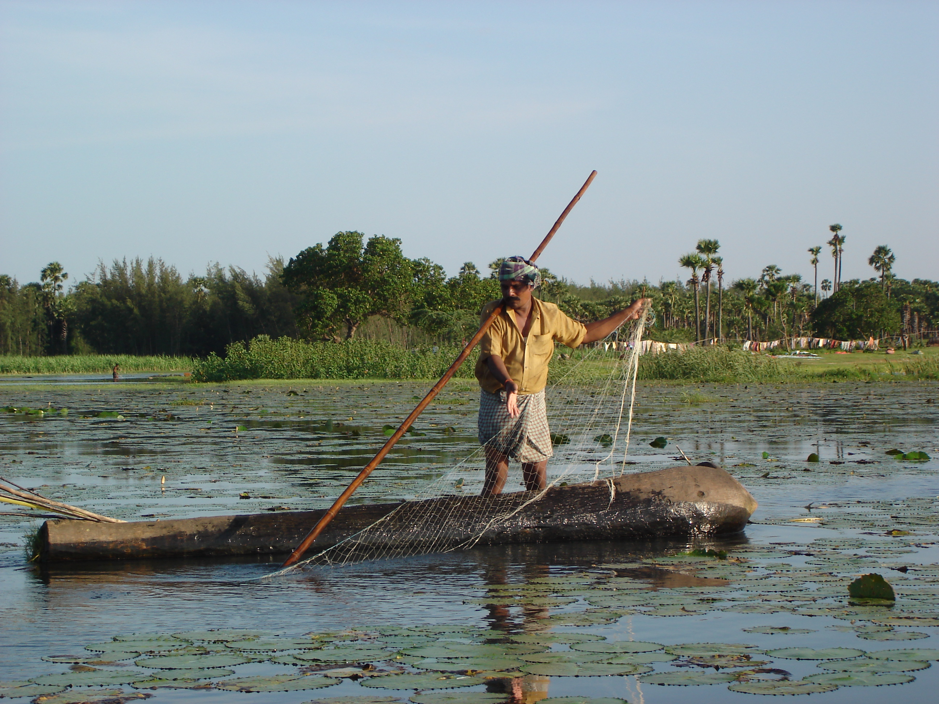
The Ava or wetland was already facing the problems of decreased water holding capacity, decrease in the level and area of water, increased pollution levels as well as decrease in the bird and fish population. The activities causing these problems were identified as deforestation, excessive use of water for irrigation, encroachment in the marginal wetland areas for cultivation, increased conflict between user groups leading to mismanagement, use of inorganic fertilizers and chemical pesticides in agricultural field and the use of wetland for washing cloths.

In the year 2003, which was also a drought year, the problem reached its peak with the Ava fully drying up for the first time in the history due to excessive irrigation supplies affecting the livelihoods of several subsistence users. This lead to heavy biodiversity losses and conflict among the users as well as the upstream and downstream villages.

A youth group based in Vishakhaptnam which had been closely following the livelihoods and biodiversity aspects in the region decided to intervene. Through their initiative ‘Save Ava’ they began work with the villagers to identify problem areas and facilitate revival of the wetland biodiversity and livelihood. The activities carried out during the years 2003-04 helped the group and villagers to identify and focus on the issues/problems plaguing the wetland and responsible for the resultant environmental degradation. The years 2004-05 brought people together and led to cultivation of mutual understanding among the various stakeholders besides assured participation of marginalized sections, thus leading to an environment where institution building was possible. During 2005-06, the Ava Development Committee was formed comprising of various stakeholders. This phase concentrated on their capacity building.
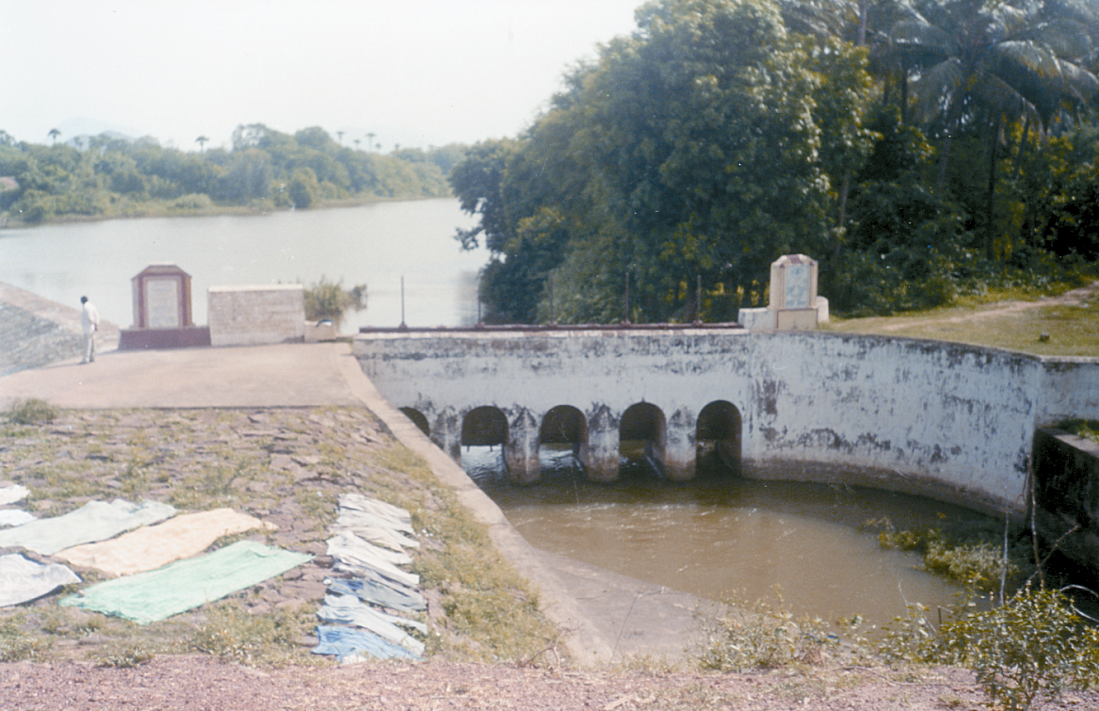
Although the formation of the committee has been facilitated questions on the sustainability persists as ground realities and challenges for the working of the group are enormous. Considering these particulars the Save Ava group has decided to continue to work to remove obstacles in the smooth functioning of the joint Ava management group by generating awareness about the rights and responsibilities of the stakeholders as well as ensuring the effective implementation of the National water policy 2002.

Discussions – Jayati’s presentation evoked a number of responses from the participants. Prof. Malhotra after congratulating her on the excellent work done asked her to further work upon removing outside and distant interventions as the group worked from Visakhapatnam. He also wanted clarification on the setting up of the committee which does not have members belonging to the previous committee, this he feels will increase the number of committees adding up to the already mammoth number of committees working there. This doubt was raised by other members as well who wanted to include all the stakeholders of the wetland. Jayati promised to look into this matter
The third Presentation was on “Laws, Legislation & Policy of Wetlands in India in general and in mountain areas specifically – Is there a way forward for active policy change” by Mr. B. J. Krishnan. Mr. Krishnan started his presentation with a warm welcome to all the participants and thanking Mr. Pratim Roy for inviting him to give a talk. He started with his experience of seeing the environmental movement grow in India and the younger generation growing up and taking responsibility for the environmental movement.
Firstly, he clarified what is a wetland as per governmental rules and the legislation that are meant to protect wetlands. Wetlands are not defined in any legislation of the country and there are some few and weak attempts to expalin. The status of the wetlands depends on the land (location) where it falls – that decides the legal position.

Land can be classified as either under `public ownership’ or `private ownership’. Under public ownership, land can either be owned by the forest department or by other agencies of the government – like revenue or grazing lands. Legal protection under revenue status is practically nil as wastelands and wetlands are considered identical in status. Under FD ownership, there are different rungs in the ladder:
- forest lands
- reserved forests
- protected areas
These are covered by the following 5 enactments:
- Indian Forest Act, 1927
- TN Forest Act, 1882 and other state enactments (in the context of TN)
- Wildlife Protection Act, 1972
- Biological Diversity Act, 2002
- Environment Protection Act, 1986

Forest lands and RFs are covered under the TN Forest Act and the Indian Forest Act. However, under the categorization of forest lands, the effort to impose the law is very weak though lands under RF, in the Deccan Plateau region are well maintained. In the local context, Longwood Shola is well protected not because it is a wetland but because it is a RF. More than the respect for the Wetlands, it is the fear of the law which keeps the biotic pressure under check.

The Wildlife Protection Act was the brainchild of Mrs. Indira Gandhi. In 1980, the Forest Conservation Act was enacted. An amendment u/s 217 in 1991, defined land as now including marshes & wetlands, including boulders and rocks. This was the first time that wetlands were specifically mentioned in legal terms. All Protected Areas (Sanctuaries & National Parks) come under the WP Act and we find that most of the remaining wetlands are within the 60 odd PAs in the country, where the focus still remains on the wildlife rather than the wetlands. The FD is legally obliged to protect the habitat.

The 7th and 8th darfts of the Biological Diversity Act were finally adopted in ’02. Section 37 of this Act can be used implemented even in private lands as the Act does not differentiate the land categorization. Certain sensitive areas can be declared as `biodiversity heritage sites’, without adhering to the Land Acquisition Act. The procedure for this is very simple.
The Environment Protection Act can be invoked in respect of private lands. There is an effort to bring the whole of Nilgiris under this Act. Under Rule 5 & 6, environmentally sensitive zones can be declared by the district administration because of biological diversity, topography, climate conditions – this then has to go upto the state government which tentatively declare the area under the Act. That has to be then dealt with the Central Government. Very importantly, wetlands which do not enjoy any protection under any Act, can use this, even in Nilgiris.

Moving on, he mentioned that the folloing policies played an important part in the environmental scenario:
- National Conservation Strategy, 1992: omnibus policy; Section 31 provides for identification and preparation of management plans for wetlands and mangoves
- National Action Plan on Biodiversity, 1997: the Govt of India acknowledges that there is no comprehensive Biodiversity Strategy. However, there is an eco-system classification given to wetlands and it lists pre-dominant wetland types
- National Environmental Policy, 2004: it is not yet notified; some of its salient features are setting up a legally enforceable mechanism, participation of local communities, eco-tourism, at time of environmental appraisal keep wetlands in mind as entities of incomparable value. The Govt of India considers wetlands as a source of water.

Internationally, the following are the `Green’ blueprints which need to be kept in mind with reference to wetlands:
- Man & Biosphere Programme (UNESCO), 1971
- Ramsar Convention
- Bann Convention, 1979
- Agenda 21

After providing this extensive background information, he talked about future projections where he felt constrained to state that there no comprehensive conservation oriented mountain and wetland policies. However, the Environment Policy gives some opening both for wetlands as well as mountain ecosystems. Because these systems are fragile, the context of sustainability becomes very important. Hence, some of the following issues need to be kept in mind:
- adoption of best practice norms for infrastructure development
- promotion of traditional agriculture & horticulture
- promotion of sustainable tourism
Overall, there should be an area specific planning, strategy and action plan which would take these into account.

Lunch and thereafter, Movie for late entrants

The fourth presentation was on “Methods to Assess Wetland Biodiversity Features” - Biodiversity tools, Sampling methods, population counts, environmental parameters presentation by Dr. S. Narendra Prasad from SACON, Deccan Office, Hyderabad.

The presentation focused on defining the terms involved in assessing the wetland biodiversity features and classification of various parameters under broad terms as per Ramsar guidelines. Baseline inventory, Species-specific assessment, Change assessment, Indicator Assessment, Resource assessment was explained.

The second part of the presentation focused on the database preparation and management for wetlands. Details on the wetland classification as well as GIS mapping was presented. The methodology for mapping wetlands was presented along with the Ramsar classification for wetlands. Broad details of wetland plants, fishes, amphibians, birds and reptiles was presented to showcase the biodiversity as well as share the

SACON has prepared a database for the wetlands of India. The database provides information through maps as well as provides access to biodiversity related information of the particular wetland. The databases’ importance as an effective information dissemination tool was demonstrated. It is user friendly as well as efforts is on to make it more accessible by providing information in regional languages.

Dr. Prasad’s presentation was received well. Prof. K. C. Malhotra congratulated the efforts but added that the entire program was scientific and missed out on the ‘Peoples aspect’. According to him the people depended on the wetland were unconcerned about the ‘Ramsar ‘status but concerned about their livelihood which depended on the wetland.
Anita from keystone felt that though the people aspect was missing it was equally important to look at other life forms depended on wetlands and so the database and inventory by SACON was a very essential component for managing wetlands.

The final programme of the day was a Panel Discussion amongst all the participants and the official stakeholders on “Governance & Wetlands”: Perspectives from the Forest Department / Government / Civil Society – how is it dealt today and the role of wetlands as invisible resources

The next session was a panel discussion facilitated by Mr. K. C. Malhotra & Pratim Roy.

Government, civil society organizations as well as indigenous people put forth their views in this discussion.

The TWAD is the official government board for ensuring water supply to the residents for Nilgiris. They explained to the participants that the board has brought out a new vision and mission for its work. Through this they plan to make their work participatory. In this way they plan to make the sources that are tapped sustainable as well as ensure peoples support in such decisions.

Mr.Mohanraj from WWF informed the people that the NBR with its Shola and grassland landscape was the only such remaining habitat for the Asian elephant. He stressed the fact that it was impossible for humans and elephants to share the same water hole. So conservation was an essential part. The locals definitely had their rights over water but as humans it was their moral duty to conserve the resources for wildlife as well.

Mr. Rathin Barman from Aaranyak, Assam shared his experiences of working on wetlands with various stakeholders. According to him the first step towards addressing any wetland problem was the identification of stakeholders- individuals, agencies, government departments and assessment of dependence based on needs. He stressed the fact that for any conservation activity it was imperative to address the economical needs and for this quantification of dependence was necessary. He also explained that from his experience ‘education and awareness generation activities were needed for all stakeholders including politicians and others part of the decision making process.

Dr.Narendra Prasad: He stressed the need for a scientific assessment and approach to understand wetlands.

Dr. Madhu, from the central soil and water conservation research and training institute conveyed to the group some facts on the unscientific landuse in the Nilgiris. According to him the current practices of agriculture are generating four truck loads of silt everyday and leading to inefficient water use. Since the wetlands in Nilgiris are small and as such ineligible to become Ramsar sites the need was site specific analysis. He stressed the need to understand the causes of degradation as well as encroachments on these wetlands. Based on the analysis restoration and other activities could be carried out. All stakeholders should be targeted while spreading information and awareness generation activities including rural and urban schools, Panchayat offices and related government departments.

A Toda elder Mr. Kuttan attended the conference. Talking about wetlands he said that it still formed an intrinsic part of their life. According to him the forest department policies of planting eucalyptus and other plants replacing the original Shola vegetation has been the root cause of drying up of wetlands in the region.

A Kota from Tirsigadi voices his views on the issue. According to him more than 50% of the wetlands in the area have dried up. Earlier they were depended on the wetlands for their livelihood as they sourced the clay for their pottery work from the wetlands. Floods, soil erosion and agricultural activities have led to massive loss in wetlands. However due to the cultural significance attached to pottery works even today, some wetlands have been preserved by the Kota community.

The session concluded with thanks to all the representatives for attending the programme and a plan was chalked out for the next day.

Day 2

Trip to Tirsigadi village to present a better understanding of Hill wetlands

The second day discussion was initiated by Prof. K. C. Malhotra. He spoke on the increased levels of understanding on hill wetlands among the participants. According to him in Natural resource management the key is adaptive management. He suggested that the team break into groups for further discussion. Based on the discussion and presentations of day 1 he suggested that the team take up themes on
- Policy, legal and institutional aspects
- Assessment of wetlands and
- Wetlands and people (livelihood and conservation)

The discussions were to result in a declaration of which Nilgiris should include a major portion. i.e. it should comprise of matter pertaining to the Nilgiris. The members were to visualize their role w.r.t. wetlands and for outstation participants the support they could provide keystone in its work on wetlands.

As per the suggestion from Mr.Dharmalingam it was decided that the groups would take into account the landscape of the region while discussing the topics.

Closing Note

Prof. K. C. Malhotra requested the organizers to circulate the draft-declaration in a week’s time and provide the participants with 10 days time to review. The proceedings were to be sent to the participants as per the convenience of the organizers within a month.

He concluded the session by saying that the program and initiative to work on wetland was a good start but needed to drastically deviate from the scientific approach followed. According to him, action strategies must keep communities in forefront. Communities were to be joint partners in all management and action points. Even scientific approach could be made participatory in which monitoring and mapping of Nilgiri wetlands is carried out by the people themselves.

Mr.Dhamalingam praised the organizers effort of studying and mapping the wetlands and thanked the hosts for organizing the workshop and discussions on the crucial aspects concerning wetlands in Nilgiris.

